.fE
St. Theresa’s Parish Community Newsletter

Parish Priest: Fr Barry Hughes
Presbytery: 17 Drummartin St., Albion 3020
Phone: 9311 3091
email: caalbion@netspace.net.au
http://pol.org.au/albion/Home.aspx
Mobile: 0428 533 391
Polish Chaplain: Fr Marian Szeptak
Residence: 185 William St., St Albans 3021
Phosne: 9310 9057

P
9310 905
St. Theresa’s Primary School - 93119070
16 Drummartin St., Albion 3020
Principal: Rob Macklin

Mother of God Primary School - 93631734
Blanche St., Ardeer 3022
Principal: Assunta Iacovino

“Do Small Things Well”

SECOND Sunday of Lent Year A 4 & 5 March 2023

CARITAS AUSTRALIA PROJECT COMPASSION …
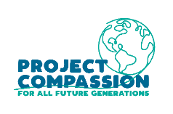
Tereesa is a Gamilaroi woman from Western Sydney who struggled with homelessness while raising her four children. Through the Baabayn Young Mums and Bubs Group, Tereesa was able to reconnect with her culture and create a better future for her children.

Please donate to Project Compassion 2023…….Together, we can help vulnerable communities face their challenges today and build a better tomorrow For All Future Generations. You can donate through Project Compassion donation boxes/envelopes available from your parish, by visiting caritas.org.au/project-compassion, or by calling 1800 024 413.

MASSES THIS WEEK  ST THERESA’S  Drummartin St, Albion  9.00am Friday  10.30am Sunday  MOTHER OF GOD  Blanche St, Ardeer  10.00am Wednesday (Pol)  9.00am Thursday  6.00pm Friday (Polish)  5.30pm Saturday  10.15am Sunday (Polish)  QUEEN OF HEAVEN  Holt St, Ardeer  8.00am Wednesday  9.00am Sunday  COMMUNITY LENTEN PRAYER  Each Friday after 9.00am Mass at St Theresa’s, we will gather at the Presbytery |  | RECONCILIATION (Individual Confession)  Saturday 11th March, 10.00am at Queen of Heaven  CUPPA AFTER MASS  Join us today after each Mass for a cuppa and a chat.  AUSTRALIAN CATHOLICS MAGAZINE  Available FREE today at all Churches, lots of good articles to read.  CHRIST’S CATHOLIC COMMUNITY  Prayer Group meets every Thursday, 7pm - 8.30pm at Queen of Heaven Church. All are welcome  COLLECTIONS RECEIVED  Thanksgiving $703 Loose Money $293 Presbytery $592  THANK YOU to our Polish Community  We received $483 this week for the people of Turkey/Syria.  COUNTERS 12th March Team 3: M Poulter, A Correya  READINGS Today Next Week  Genesis 12.1-4 Exodus 17.3-7  Ps 33.4-5, 18-19, 20+22, (R.22) Ps 95.1-2,6-7ab,7c-9 (R.7c+8a)  2 Timothy 1.8b-10 Romans 5.1-2,5-8  Matthew 17.1-9 John 4.5-42

PARISH FINANCE COMMITTEE
Volunteers required joining our Finance Committee expression of interest please speak to Fr Barry or contact Parish office on 9311 3091

FIRST PARISH SOCIAL DINNER FOR 2023 Tuesday 14th March Time: 6.00pm at Deer Park Club 780 Ballarat Rd, Deer Park…RSVP Ann-Maree by Monday 13th March on 0401 192079

St Theresa’s Parish is committed to the safety of children, young people and vulnerable adults

REFLECTION ON THE READINGS
Written by Michael McGirr

Think for a moment about some of the things you have on your walls at home. They don’t have to be fancy or expensive. They might be photos of your family or perhaps of deceased grandparents. They might be prints of famous paintings or posters with sayings that mean a lot to you. It is very common that Christians have special things: crucifixes or images of saints. All of these things inspire us in one way or another. If ever you have had to pack up to move house and looked at your bare walls as you leave, they will seem empty and colourless.
Art is one of the things that transfigures our world and makes it more beautiful. Other things do this as well: laughter, tears, cooking, music, hugs and sharing stories. They all transfigure our houses and allow us to see them as homes. They unlock the true potential of an otherwise ordinary space.
This week Project Compassion, organised by Caritas Australia, presents us with the story of Tereesa, a 27-year-old indigenous woman from Western Sydney, the area with the largest urban indigenous population in the country. Tereesa became pregnant at the age of 16.
With your help, Project Compassion has been able to support the Mums and Bubs program run by Baabayn Aboriginal Corporation. This allowed Tereesa to find accommodation, gain skills and continue her education. She was also able to connect with her culture. Her glorious artwork was featured on the Wulugul Walk during Sydney’s Vivid Light festival last year. Her use of light and colour transfigured the environment where it was displayed. In so many places, Project Compassion helps people to achieve their vision.
Of course, the transfiguration of Jesus is unique. We hear in today’s Gospel that Jesus took his closest friends to the top of a high mountain. His face shone like the sun and his face became ‘as white as the light.’ A voice from heaven said ‘this is my beloved son; listen to him.’ Peter said how wonderful it was to be there. The transfiguration may have only lasted a few minutes but it was clear that Jesus’ friends never forgot it. Like a work of art on a wall, the memory made the world seem very different. During Lent, we are also called to transfigure the world, to make a difference.

TEREESA’S STORY – AUSTRALIA

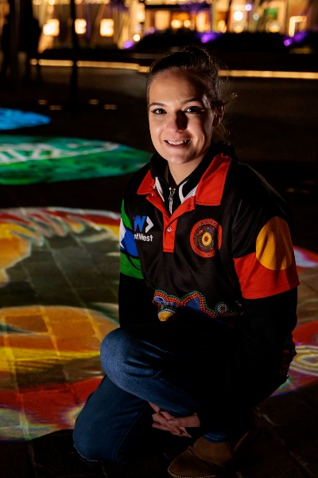
Tereesa is a Gamilaroi woman from Western Sydney who struggled with homelessness while raising her four children. At just 16 years old, she had to leave school after falling pregnant with her first child. A single mother struggling with homelessness, Tereesa’s only concern was finding stability for her children.

Seeking a better future for her family, Tereesa joined Baabayn Aboriginal Corporation’s Young Mums and Bubs Group, supported by Caritas Australia. Baabayn helped Tereesa access housing and psychological support. Today, Tereesa is studying a certificate in Community Services so that she can strengthen her skills and give back to her community.

Tereesa now works at Baabayn, providing support to young mothers and mentoring the next generation of young people.

